**SEMESTER PROJECT**

**VA &RE**

**Project 1:**

**AI-Driven Vulnerability Prioritization and Remediation System for Network and OS Layers**

**Submitted by:** Laila Tariq, Bakhtawar Ilyas, Yumna Shahzad

**Roll number:** i221574, i221665, i221571

**Date:** 5/4/2025

**Submitted to:** Sir Jawad Hasan

**Table of Contents**

• **Introduction** 3

• **Targeted Vulnerability Layers** 3

• **Steps** 3

• **Challenges** 22

• **Summary** 22

• **References** 23

# **Introduction**

This project, AI-Driven Vulnerability Prioritization and Remediation System, aims to make that process smarter and faster using machine learning and AI. We used data from the National Vulnerability Database (NVD) to identify and analyze known CVEs. Instead of relying on traditional manual review, we built models to classify the severity of each vulnerability. For this, we trained Logistic Regression and Random Forest classifiers using CVE descriptions and metadata. To suggest fixes, we integrated the Google Gemini API, which provides up-to-date remediation steps based on the CVE. This combination creates a practical tool that helps prioritize and address vulnerabilities effectively.

### **Targeted Vulnerability Layers**

To keep the project focused and effective, we targeted two key layers: the **Network Layer** and the **Operating System Layer**

# **Steps**

**PART 1: Data Collection**

Data Source: NVD (<https://nvd.nist.gov/>)

For data collection, we used keyword-based filtering to extract relevant CVEs from the NVD. For the network layer, we searched for terms like 'http', 'https', 'tcp', 'udp', 'dns', 'firewall', 'router', 'remote code execution', 'sql injection', 'xss', 'csrf', 'ssrf', 'vpn', 'ssl', 'tls', For the OS layer, we looked for keywords such as 'linux', 'kernel', 'windows', 'macos', 'android', 'driver', 'privilege escalation', 'root access', 'memory corruption', 'buffer overflow', 'system call', 'file system', 'registry' This helped us narrow down the huge dataset to vulnerabilities that are more relevant and common in real-world systems.

**MAX_RESULTS** = 20000 # Target to collect

**OUTPUT_CSV_FILE** = "cve_dataset.csv"

**--- Function used to fetch data:**

# --- API Functions ---

def fetch_nvd_data(start_index=0, keyword_filter=None):

"""Fetch CVE data from NVD API with retry logic"""

headers = {'apiKey': NVD_API_KEY} if NVD_API_KEY else {}

params = {

'resultsPerPage': RESULTS_PER_PAGE,

'startIndex': start_index

}

**--- Data Processing:**

Here we used a function that extracts CVSS data with version prioritization

def get_cvss_data(cve_item):

# Try CVSS v3.1 first

# Fallback to CVSS v3.0

# Fallback to CVSS v2

**OUTPUT:**

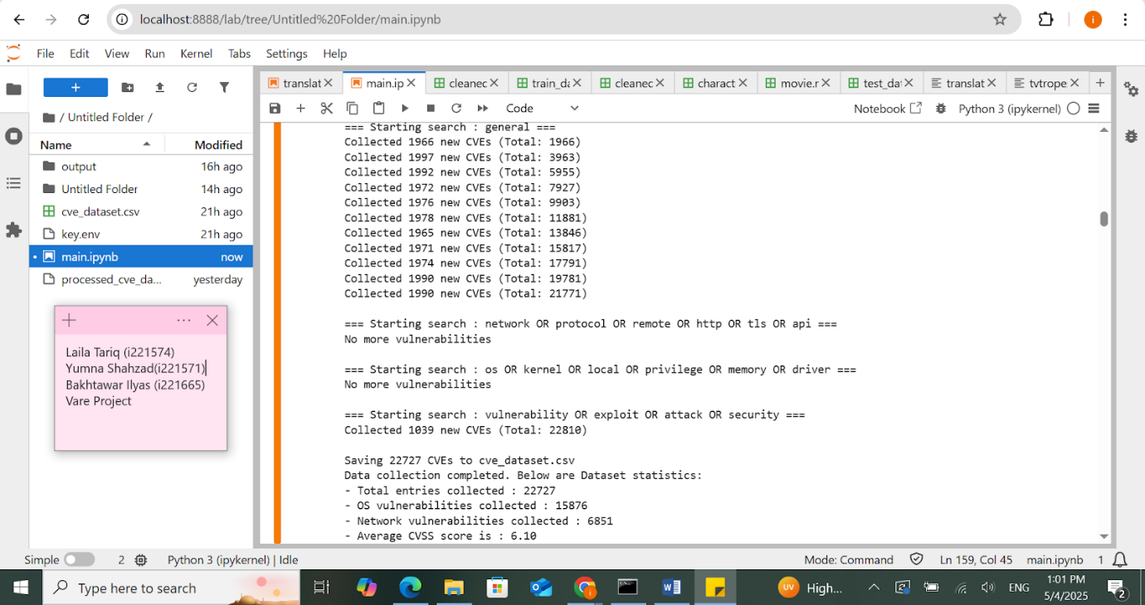

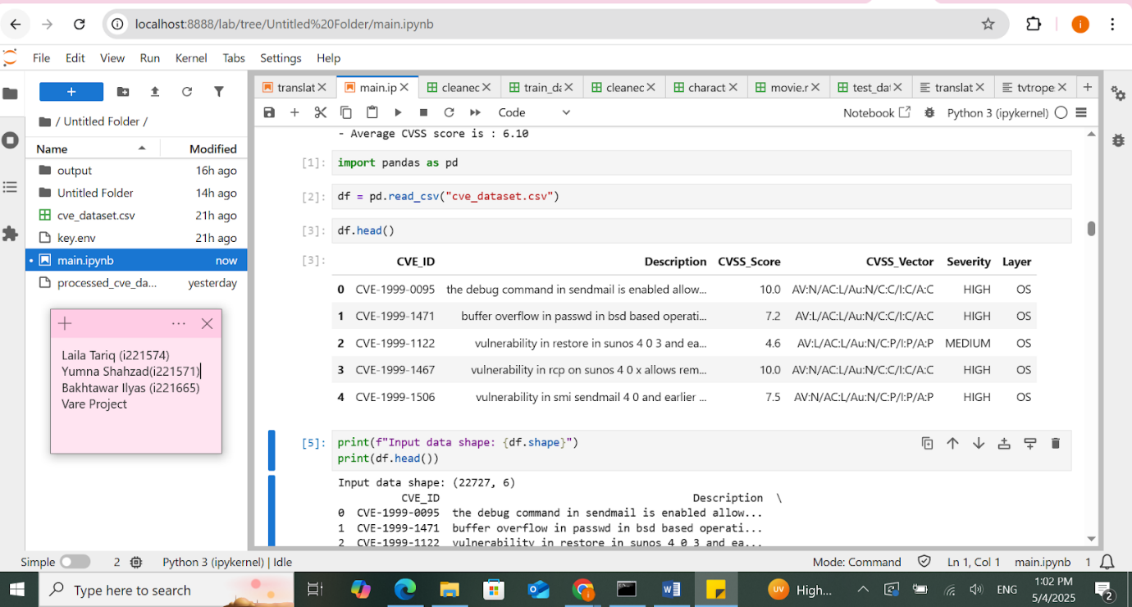

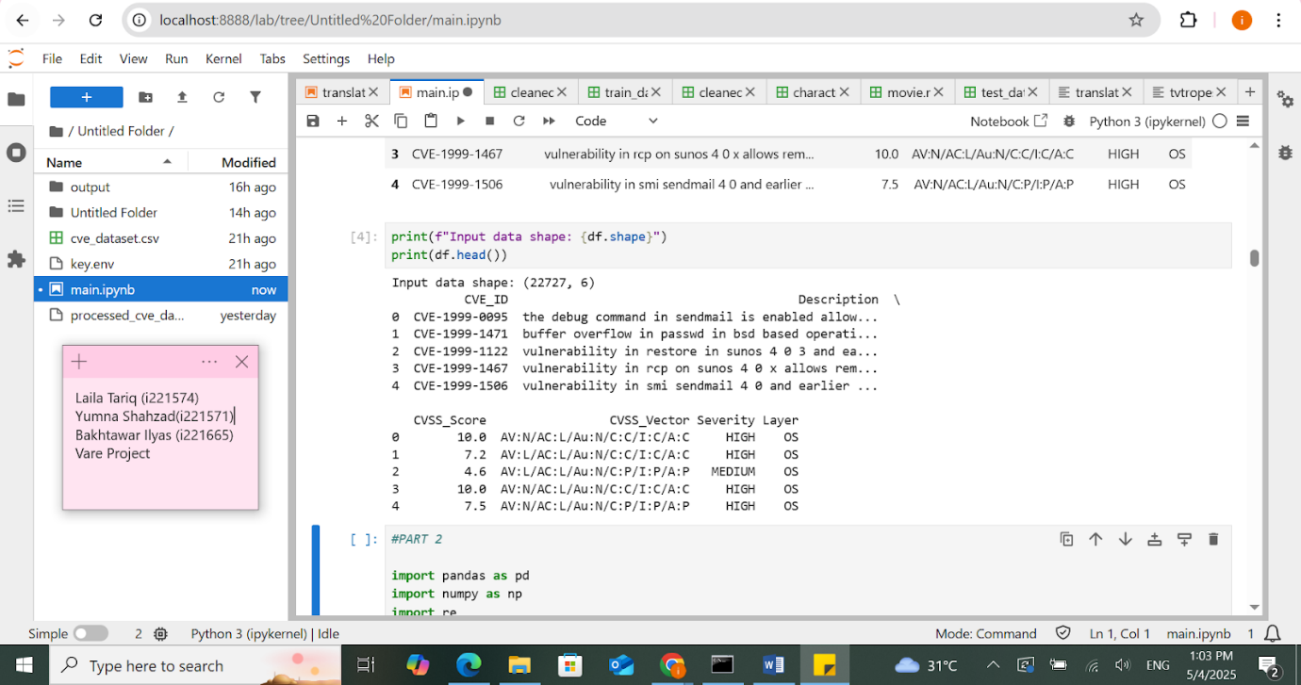

**PART 2:** **Data Preprocessing**

Before training any models, we needed to clean and prepare the raw CVE data from the NVD. This part involved several steps. First, we **extracted CVSS vector components** (like Attack Vector, Privileges Required, etc.) from each vulnerability entry, which helped add structure to the dataset. These categorical fields were then **label-encoded**, and numerical features such as CVSS scores were **standardized** for better model performance.

To understand the textual descriptions better, we generated **BERT embeddings** using the pre-trained bert-base-uncased model. Each CVE description was tokenized and passed through BERT to get a fixed-size vector that captures the meaning of the text. These embeddings were later used for severity classification and visualization.

This step was **purely preprocessing**. It didn’t involve training yet, but it prepared the raw data into a format suitable for machine learning by cleaning, encoding, scaling, and converting text into meaningful numeric form.

**OUTPUT:**

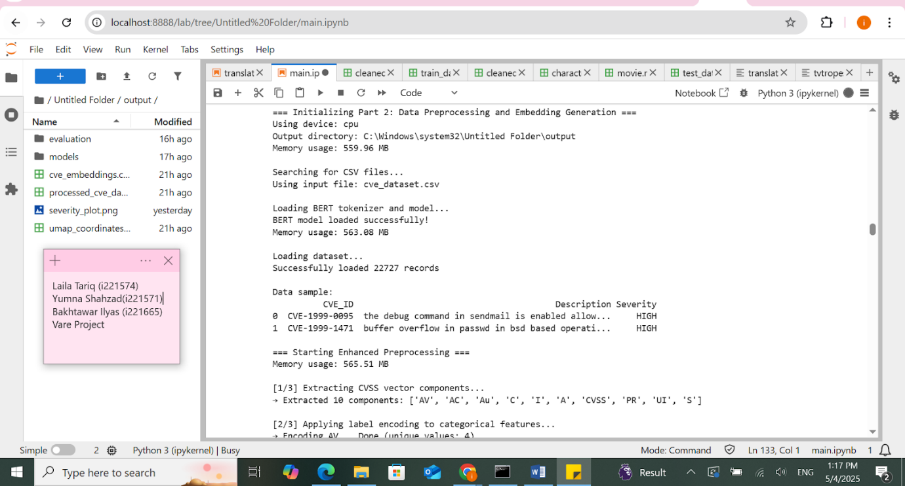

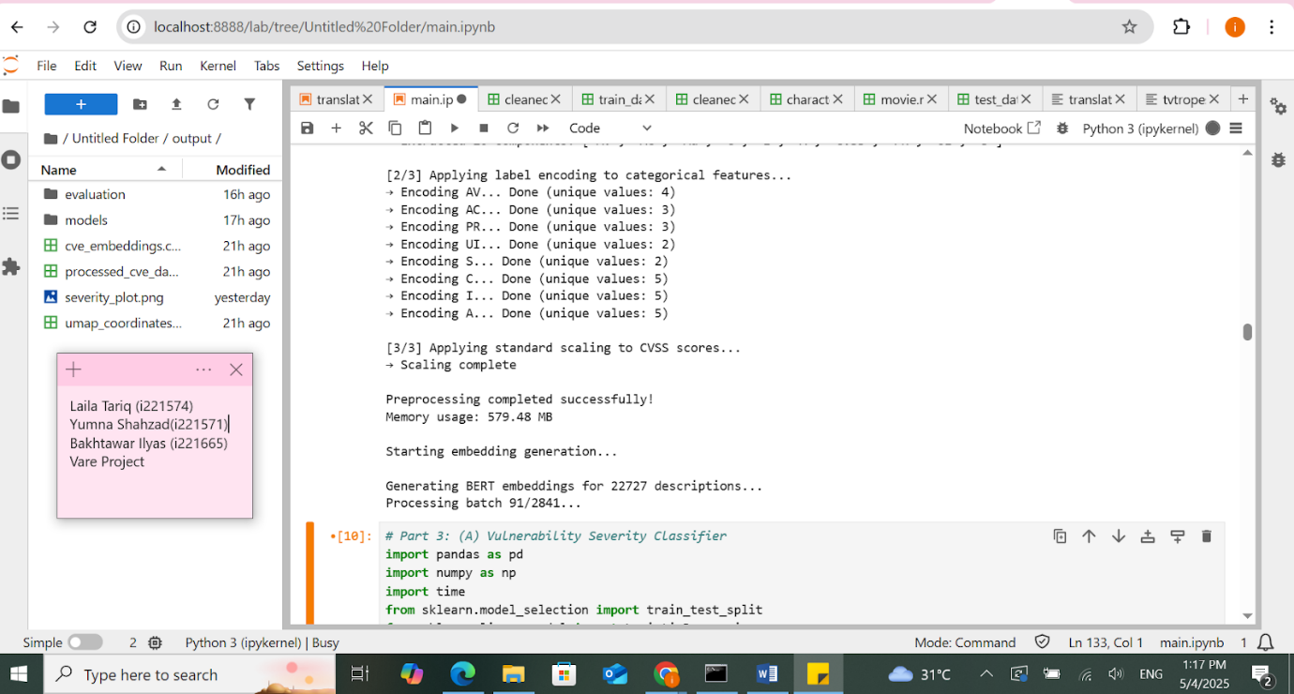

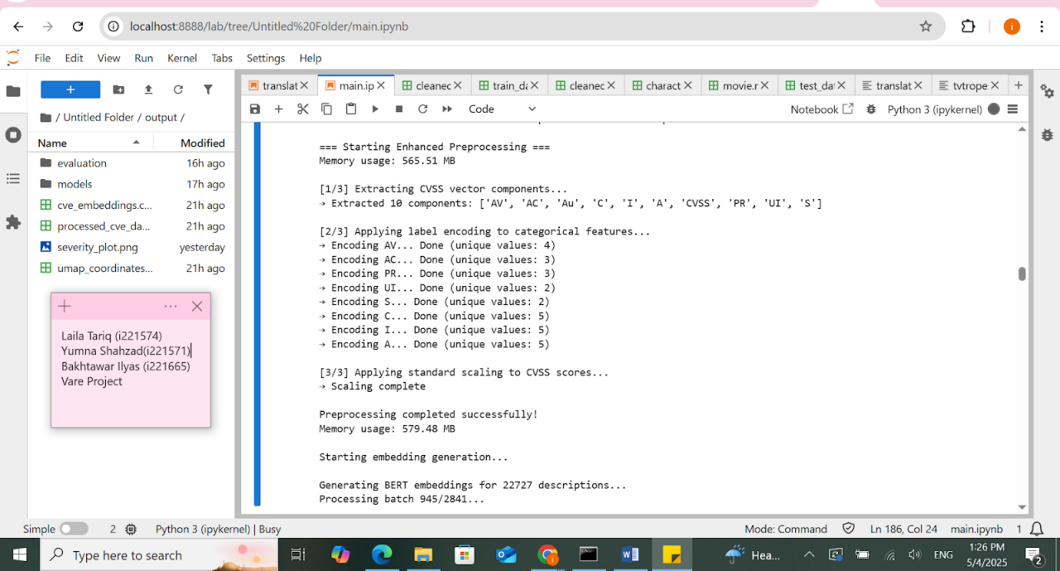

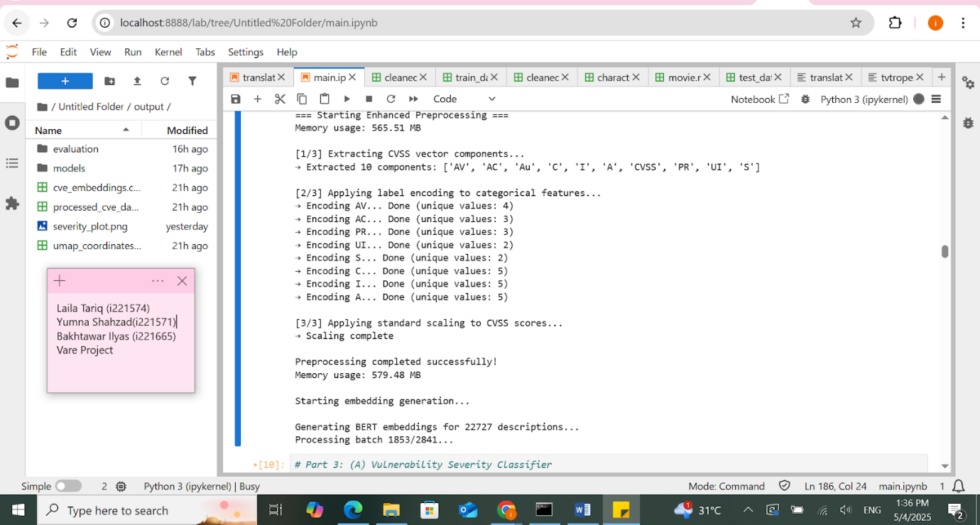

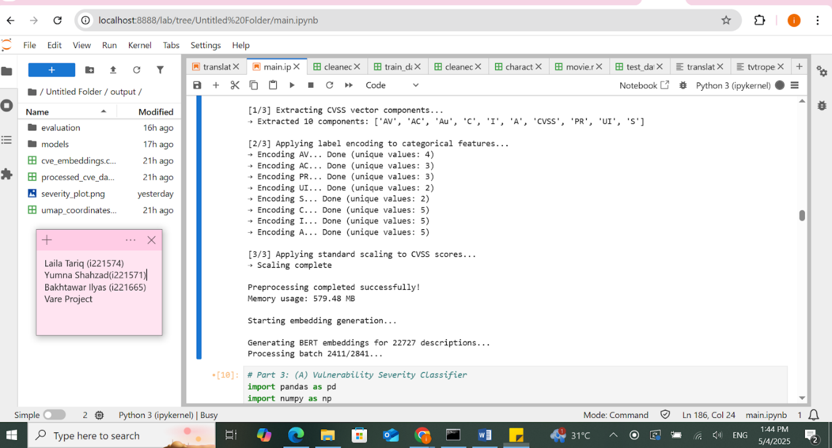

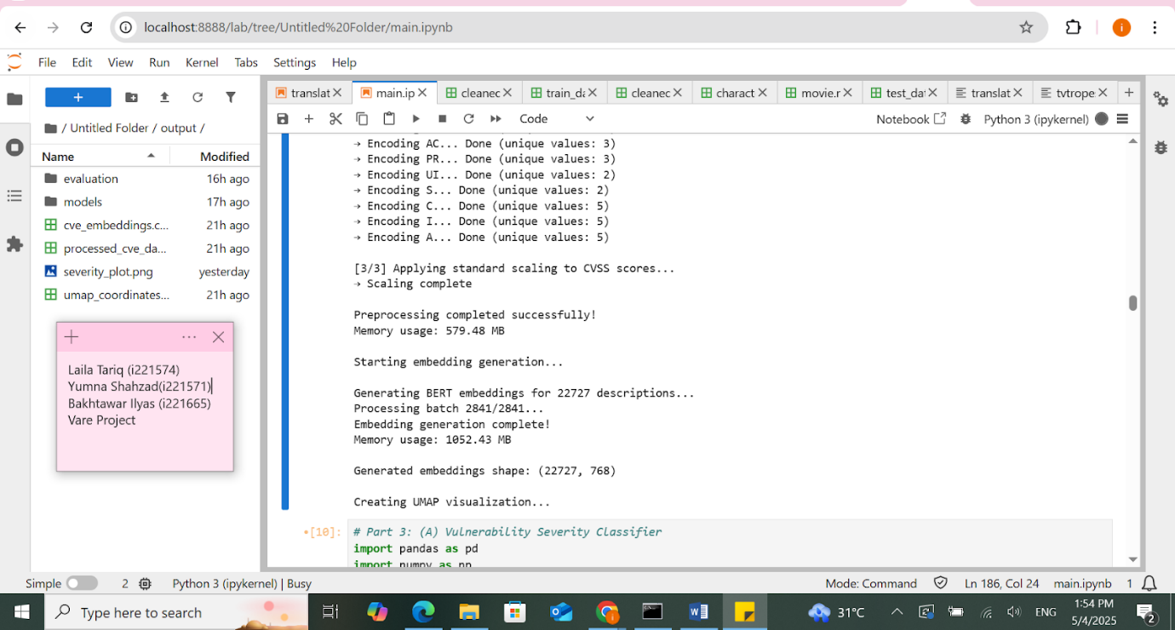

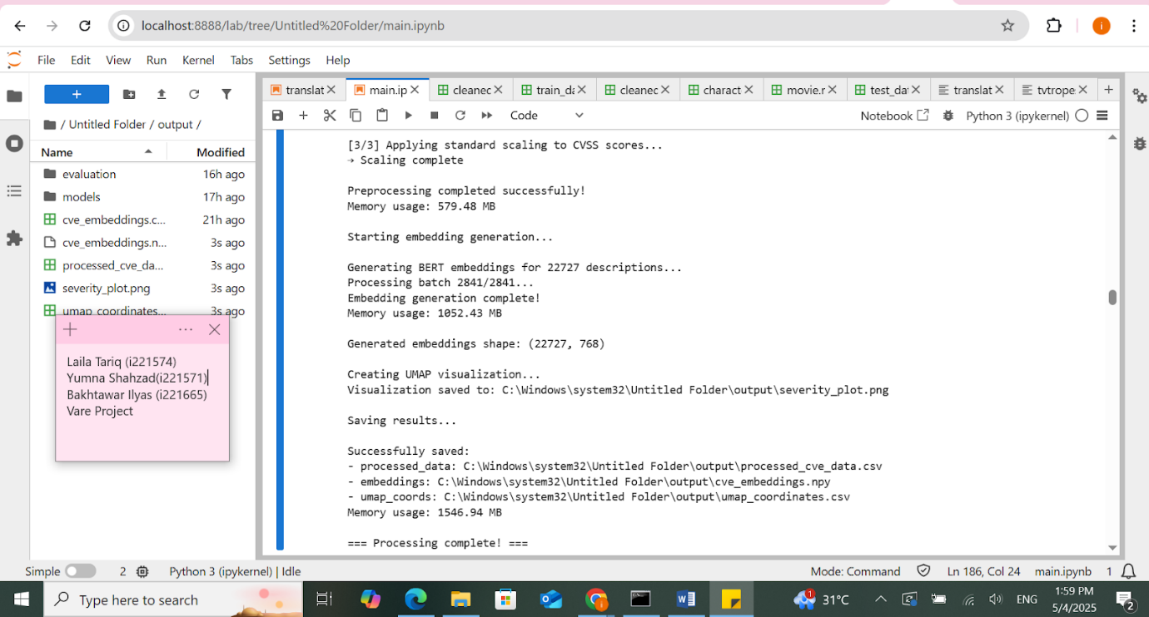

**Severity plot**

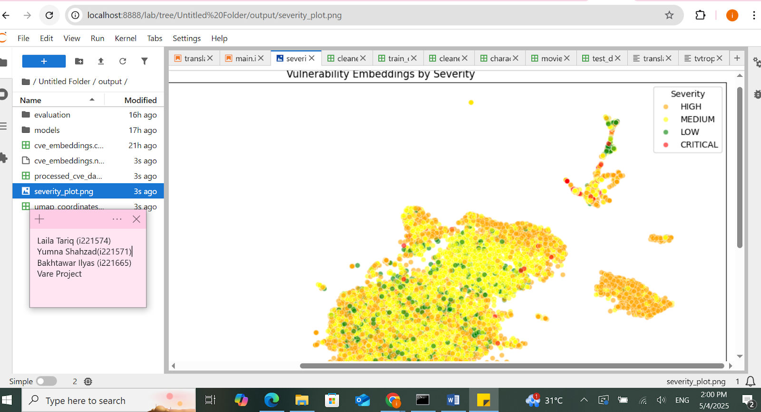

**Processed CVE data.csv**

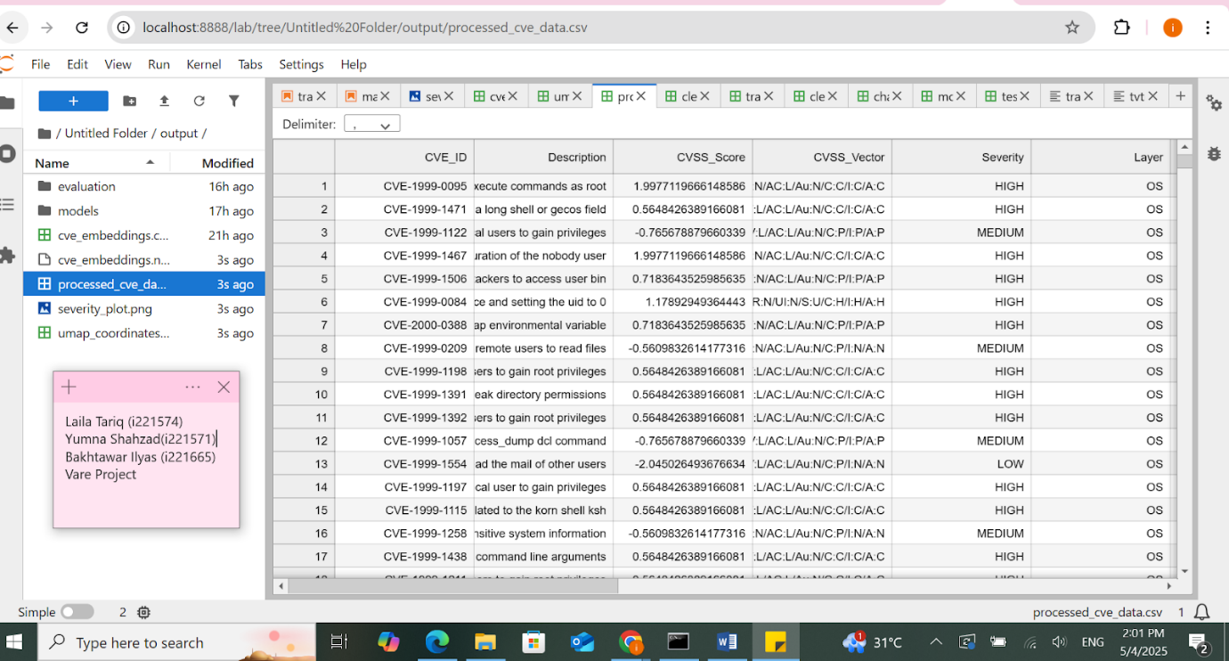

**PART 3A: AI Model – Vulnerability Severity Classifier**

In this phase, we trained machine learning models to classify the severity of vulnerabilities into **Low, Medium, High, and Critical**. The model inputs included **BERT-based text embeddings** of the CVE descriptions and structured metadata like **CVSS score and vector components** (e.g., AV, PR, UI, etc.).

The raw input features were first scaled using **StandardScaler** for better convergence. We then trained two models: **Logistic Regression** and **Random Forest**, both with class balancing to handle data imbalance across severity levels. Each model was evaluated using **accuracy and classification reports** to assess how well it predicted real-world severity labels.

**Actual model training is happening here** using scikit-learn. After training, both models along with the scaler were saved to disk using **Joblib**, allowing for easy reuse later without retraining.

**OUPUT:**

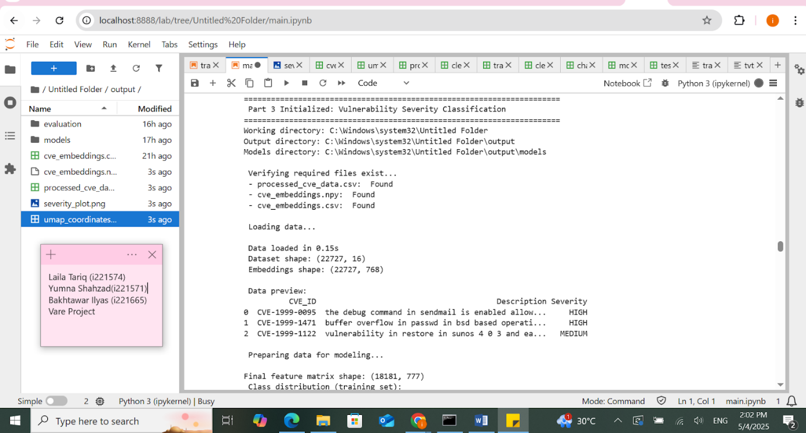

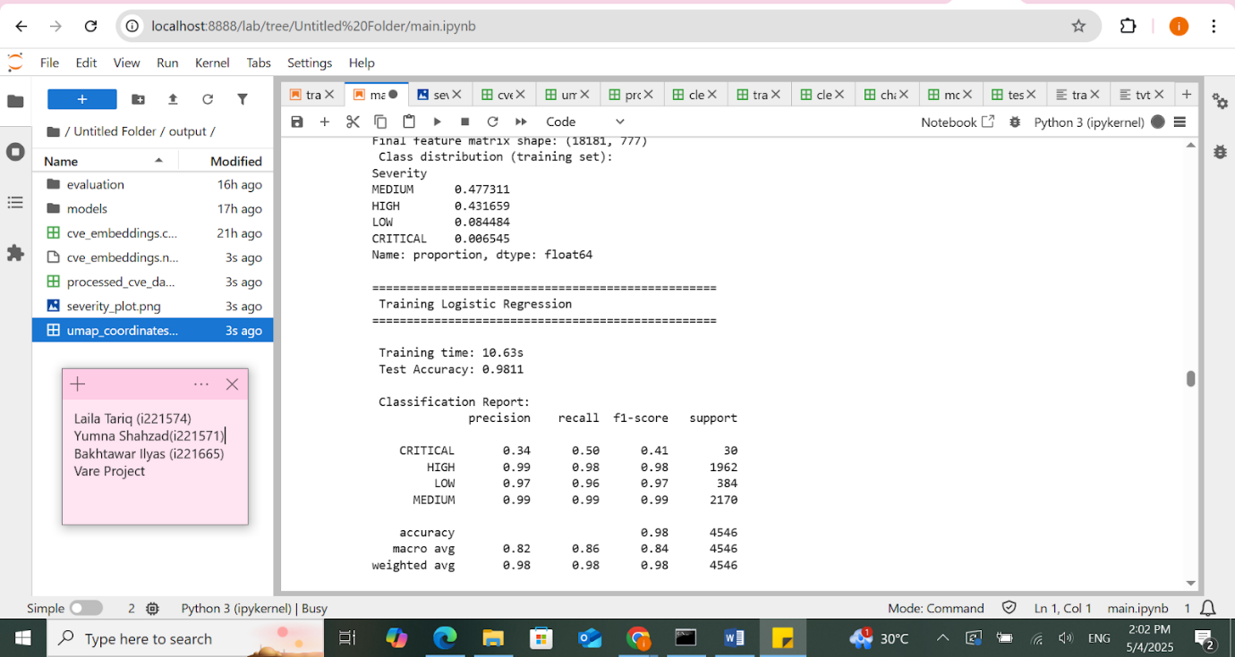

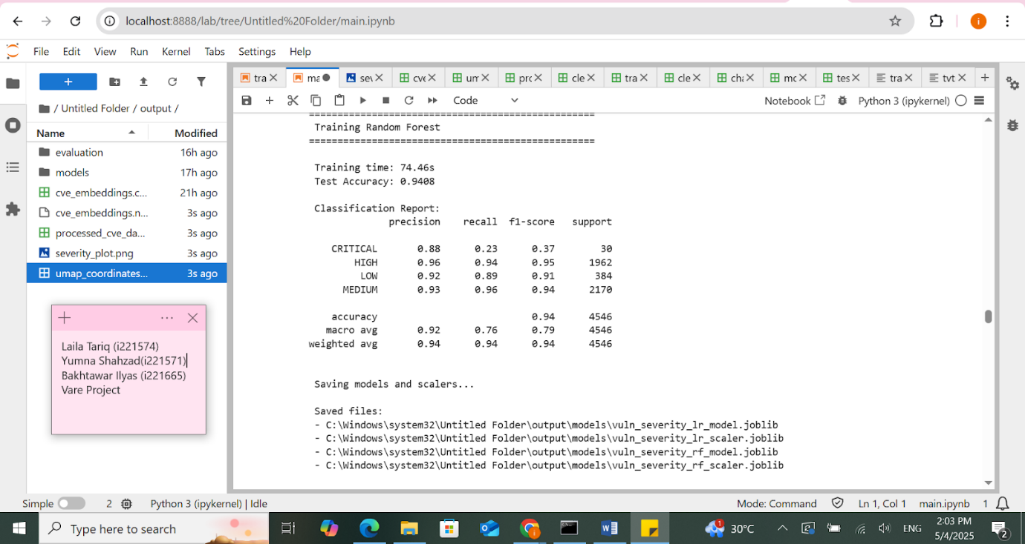

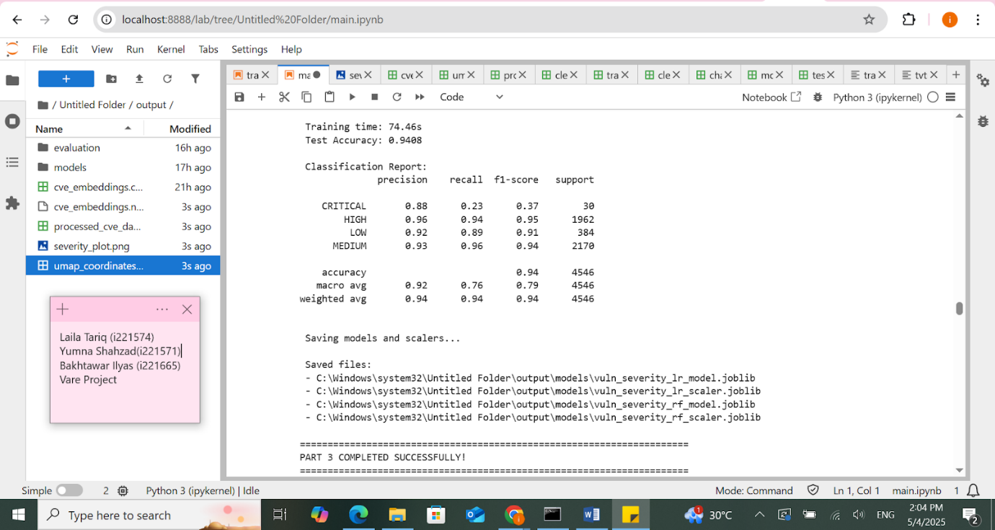

**PART 3B:** **Remediation Suggestion System**

This component aims to generate **actionable remediation steps** for vulnerabilities based on CVE data. While traditional methods might involve **fine-tuning models like T5 or using SBERT for retrieval**, we opted for a more up-to-date and scalable approach by integrating the **Google Gemini API (Generative AI)**.

For each CVE, a structured prompt is sent to Gemini’s **gemini-1.5-pro-latest** model, asking it to return a detailed remediation plan that includes:

* Containment measures
* Permanent technical fixes
* Workarounds
* Vendor patch references
* Detection methods

The system supports all CVEs but, for demonstration and rate-limiting purposes, is currently configured to **process only the first 30 CVEs** from the dataset.

**this part does not involve training any model locally**. Instead, it **uses a cloud-based generative model (Google Gemini)** to retrieve and generate remediations dynamically, ensuring the responses are **current and contextually rich**, especially valuable for newly discovered or rapidly evolving threats.

**OUTPUT:**

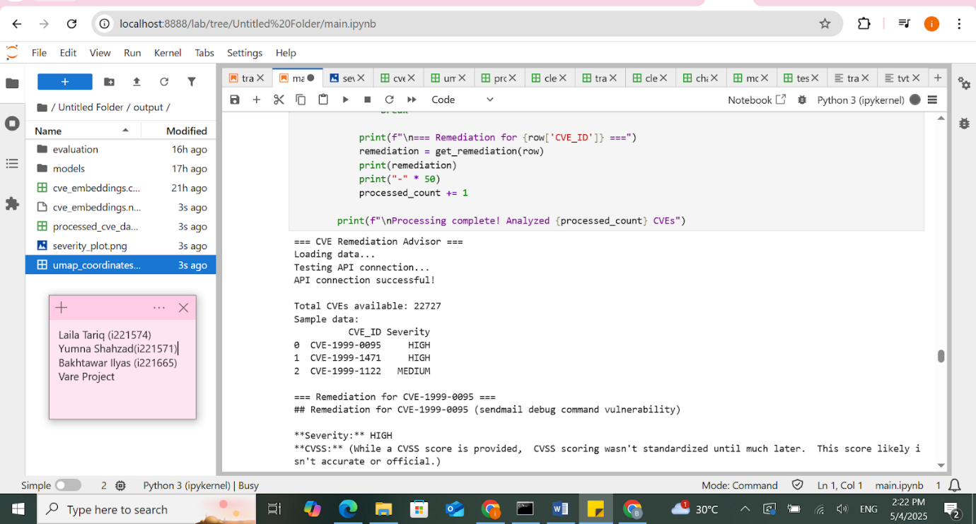

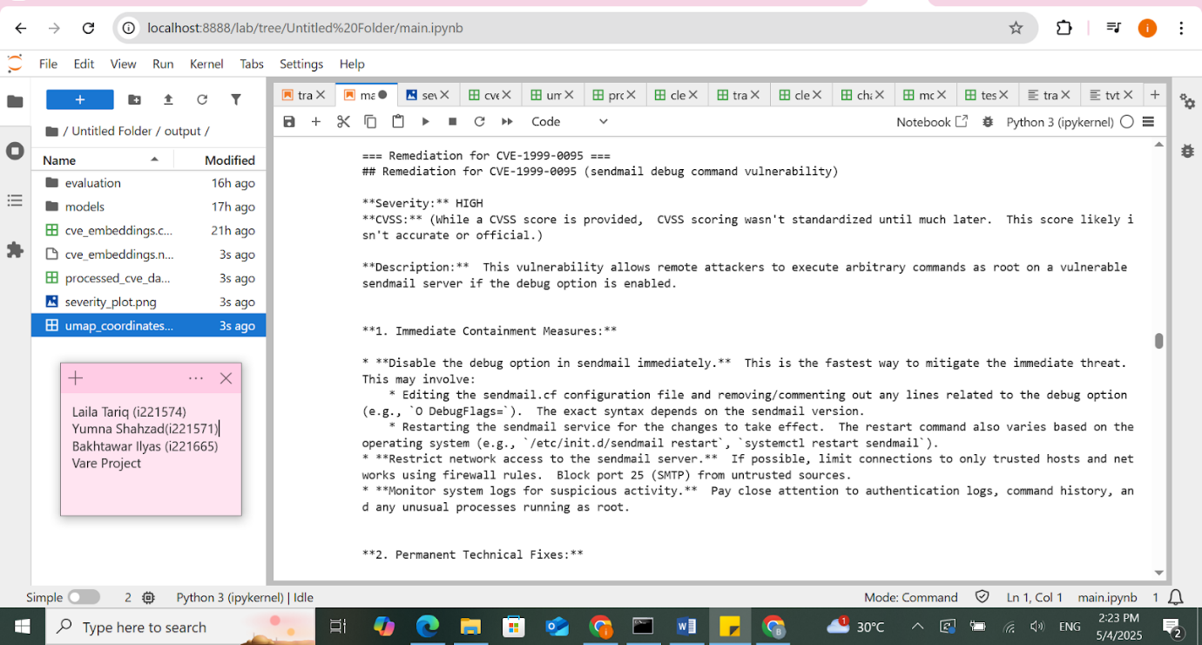

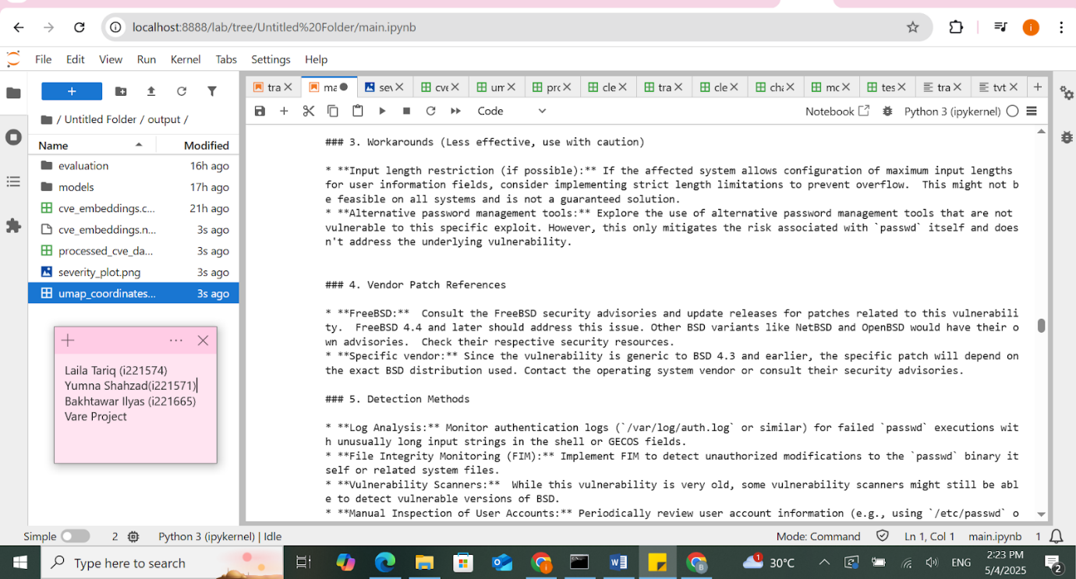

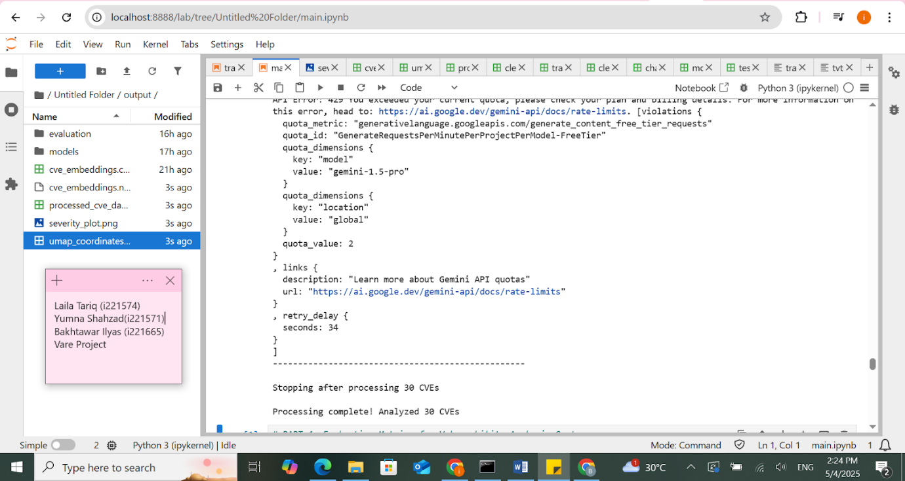

### **PART 4: Evaluation**

To assess the performance of both **classification** and **remediation generation** components of the vulnerability analysis system, we employed **standard evaluation metrics** across two dimensions:

#### **A. Classification Model Evaluation**

We evaluated two models trained to predict CVE severity: **Logistic Regression** and **Random Forest**. The models were assessed using the following metrics:

* **Accuracy**: Overall correct predictions
* **Precision**: Correct positive predictions over total positive predictions
* **Recall**: Correct positive predictions over total actual positives
* **F1-score**: Harmonic mean of precision and recall

**Results:**

| **Model** | **Accuracy** | **Precision** | **Recall** | **F1-score** |
| --- | --- | --- | --- | --- |
| Logistic Regression | 0.981 | 0.983 | 0.981 | 0.982 |
| Random Forest | 0.941 | 0.941 | 0.941 | 0.939 |

Confusion matrices were also plotted to visualize the model's classification performance across severity classes. These are saved in the evaluation directory.

#### **B. Text Generation Evaluation**

For evaluating the **remediation suggestions** generated by the Gemini API, we used:

* **BLEU Score** (Bilingual Evaluation Understudy): Measures overlap of n-grams between generated and reference texts.
* **ROUGE Score** (Recall-Oriented Understudy for Gisting Evaluation): Measures the recall of overlapping words and phrases.
* **Cosine Similarity** (using Sentence Transformers): Measures semantic similarity between generated output and a reference corpus of high-quality remediations.

A sample of **20 generated remediations** was used for this evaluation due to API cost and performance considerations.

These metrics provided both **quantitative insights (BLEU, ROUGE)** and **semantic fidelity (embedding-based cosine similarity)**, enabling robust evaluation of natural language outputs.

**OUTPUT:**

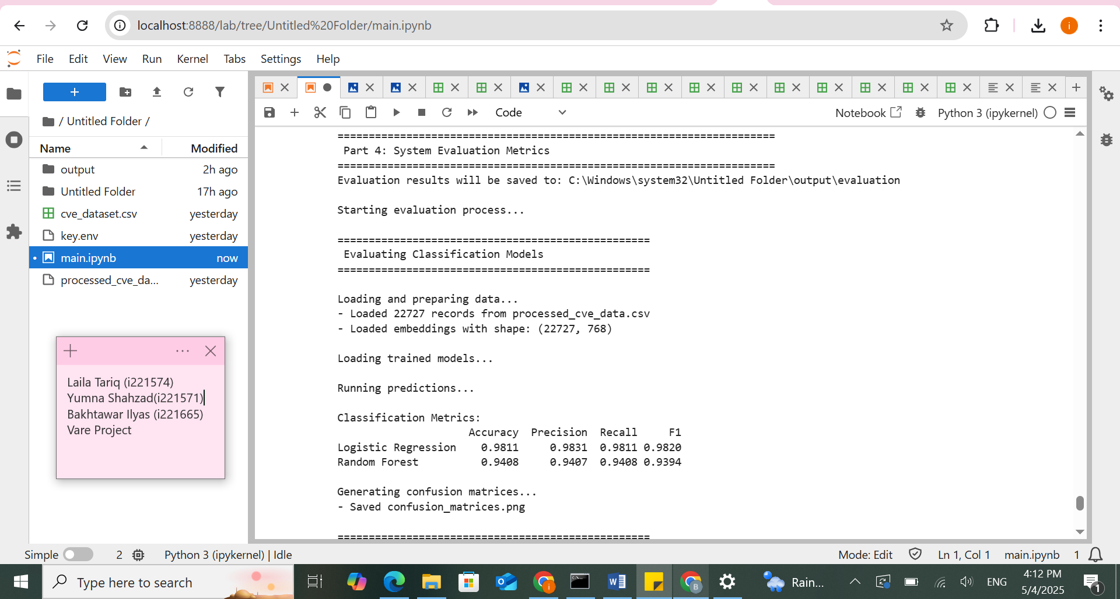

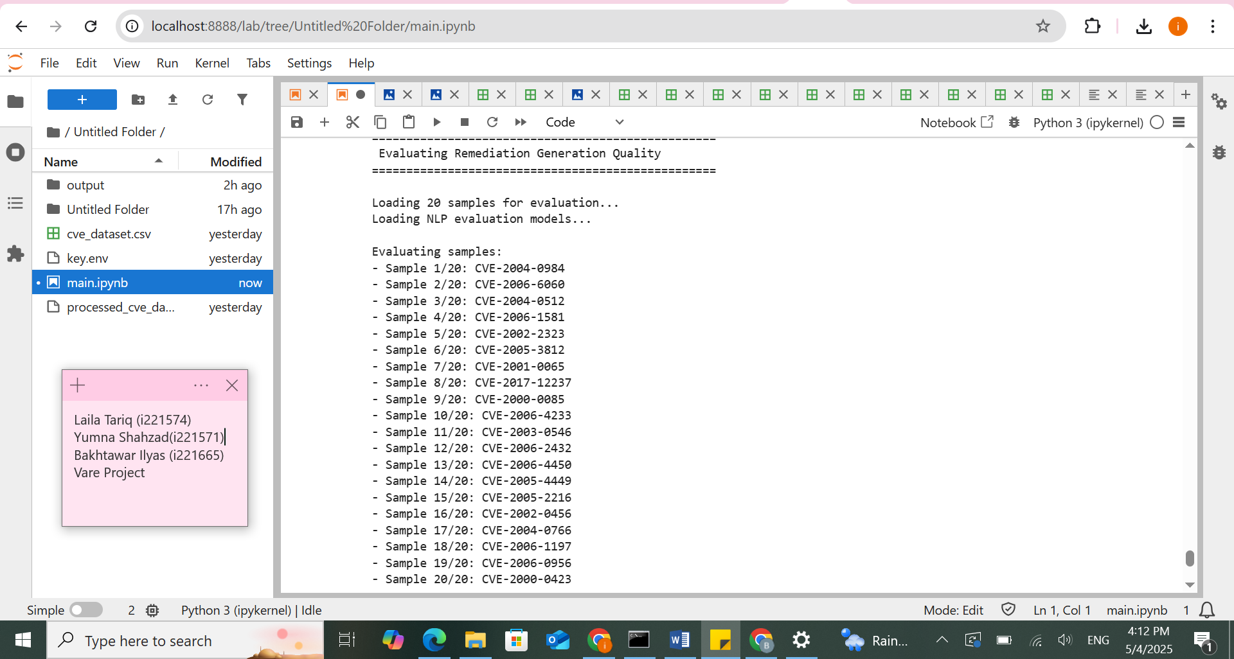

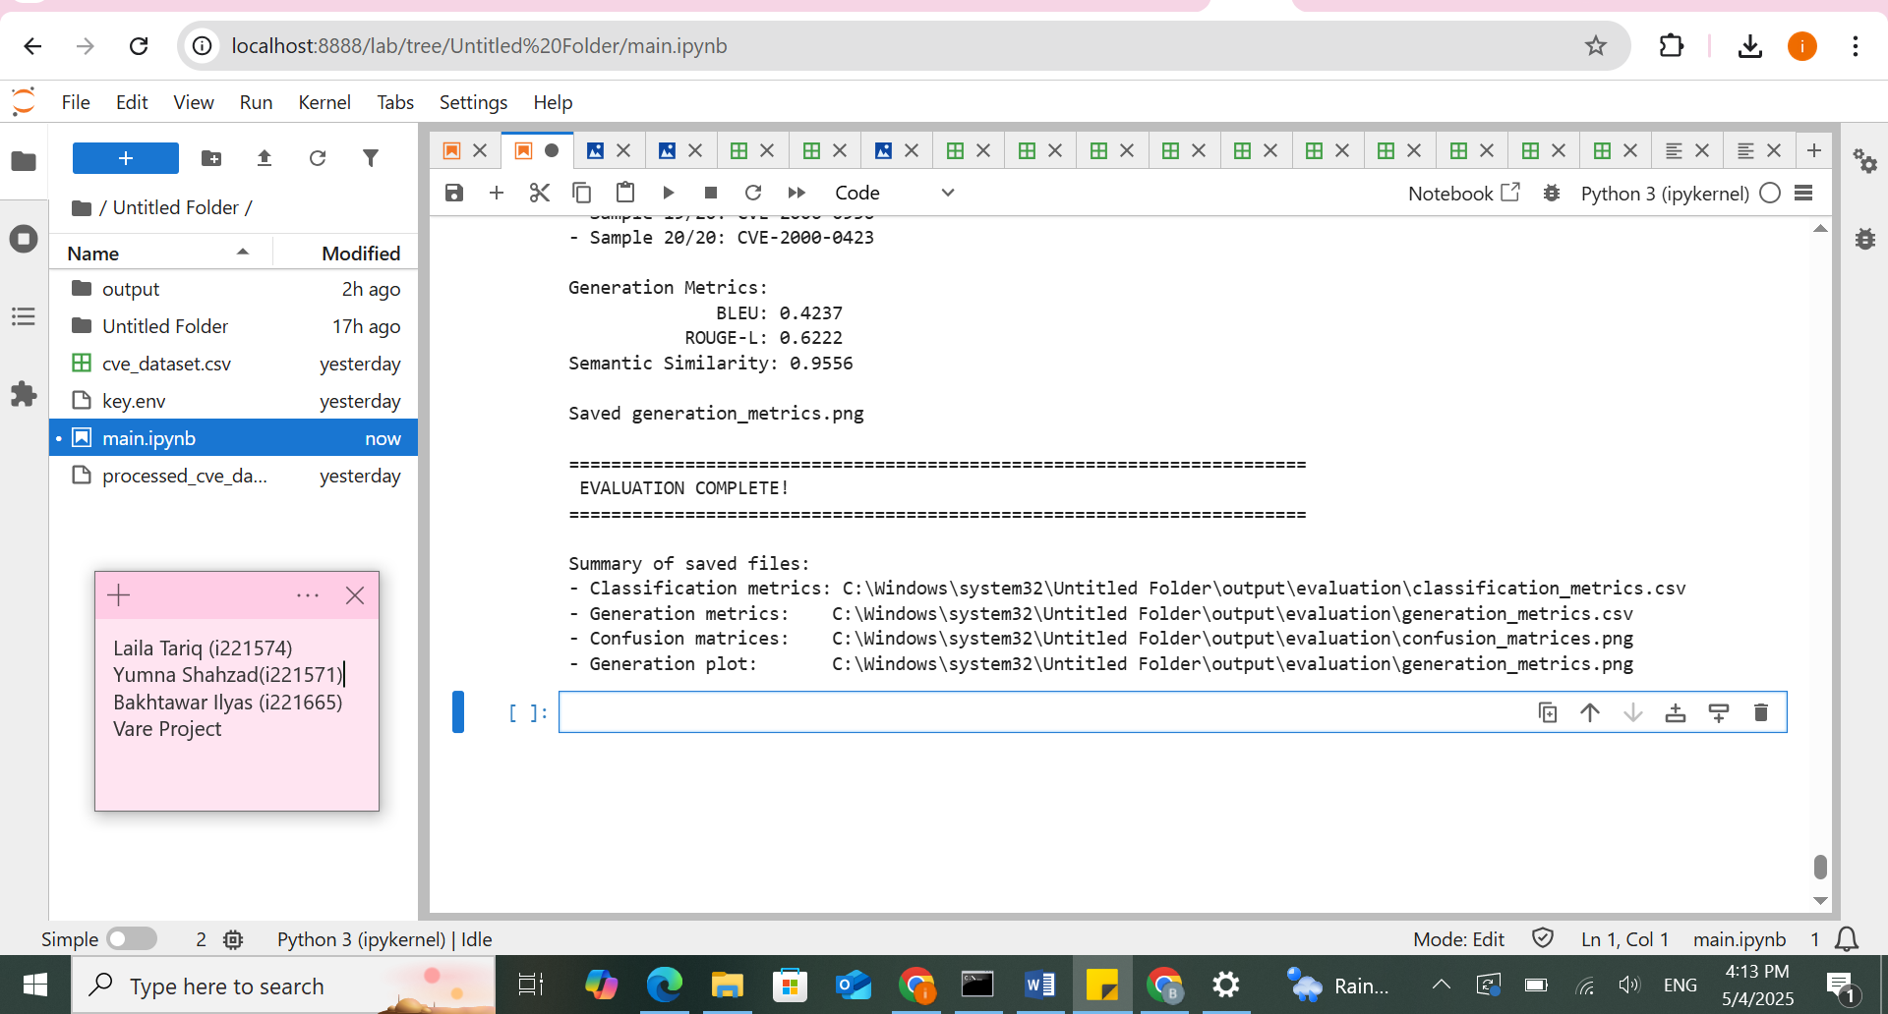

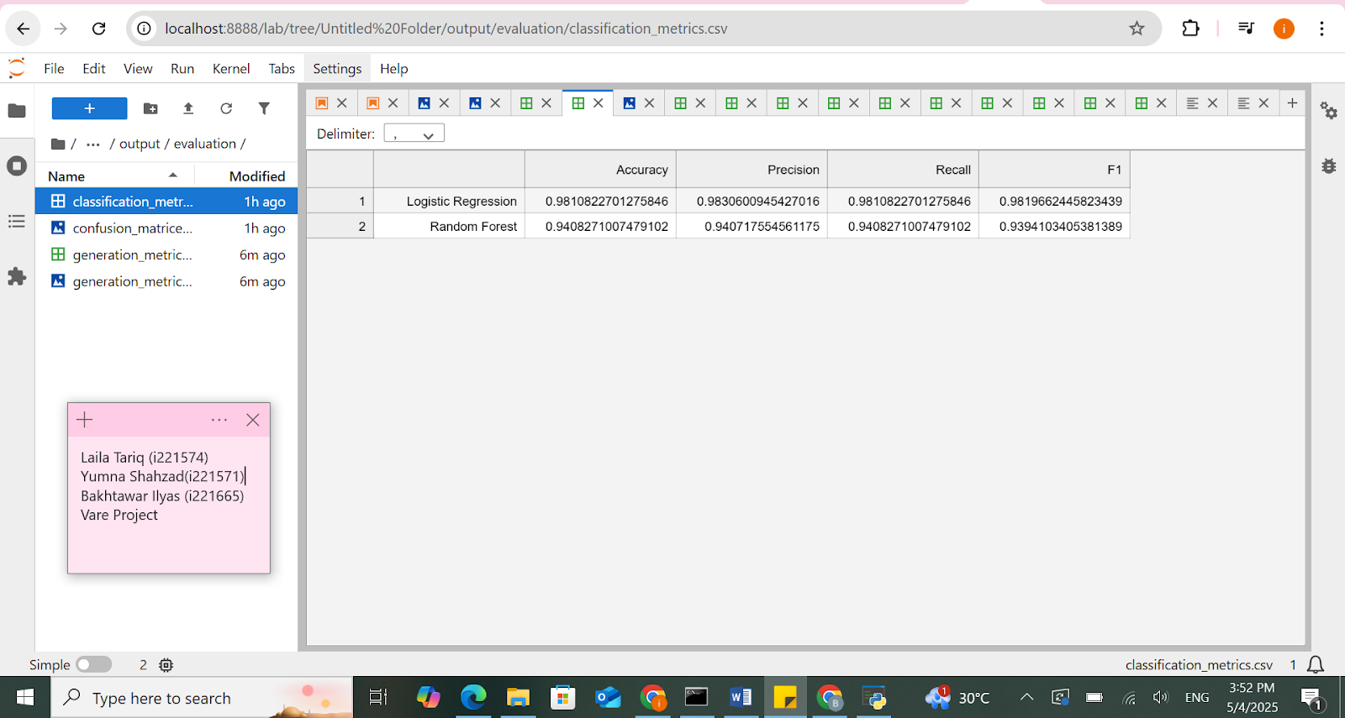

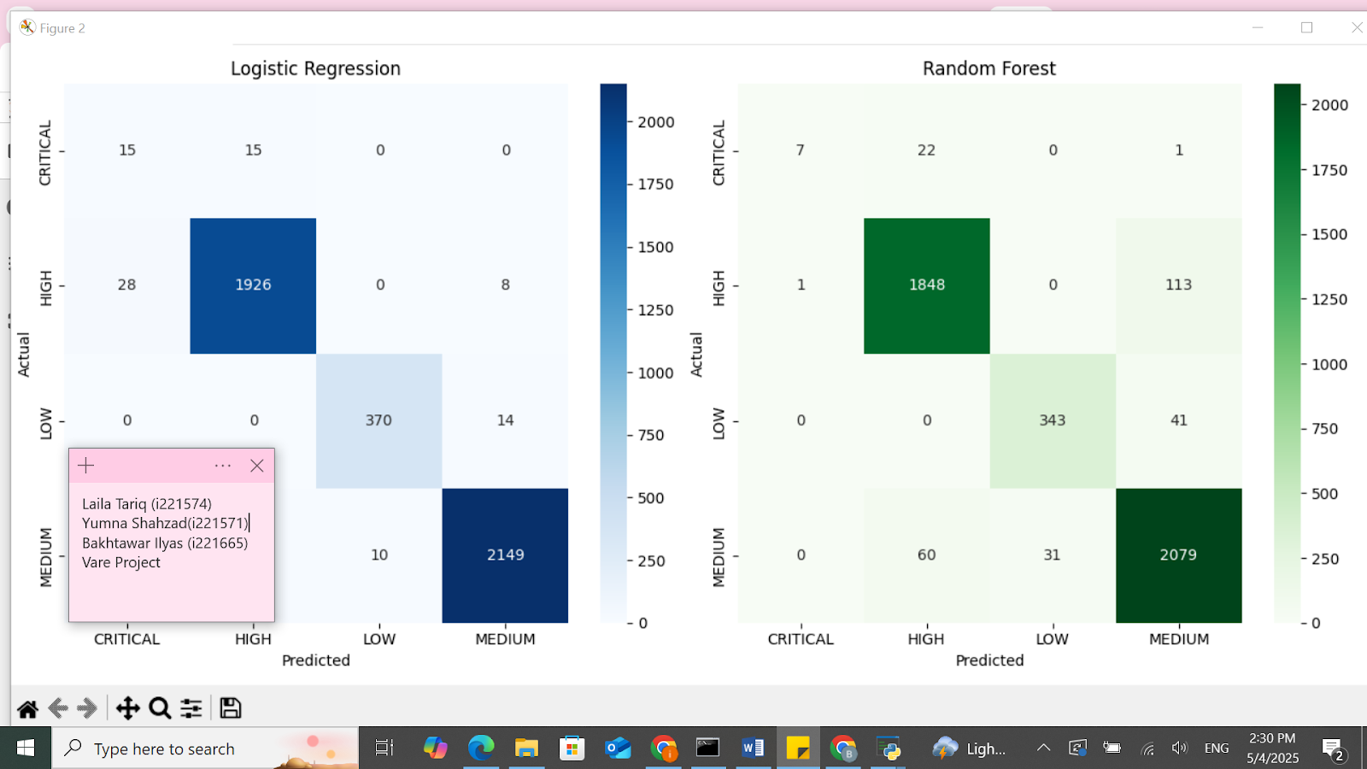

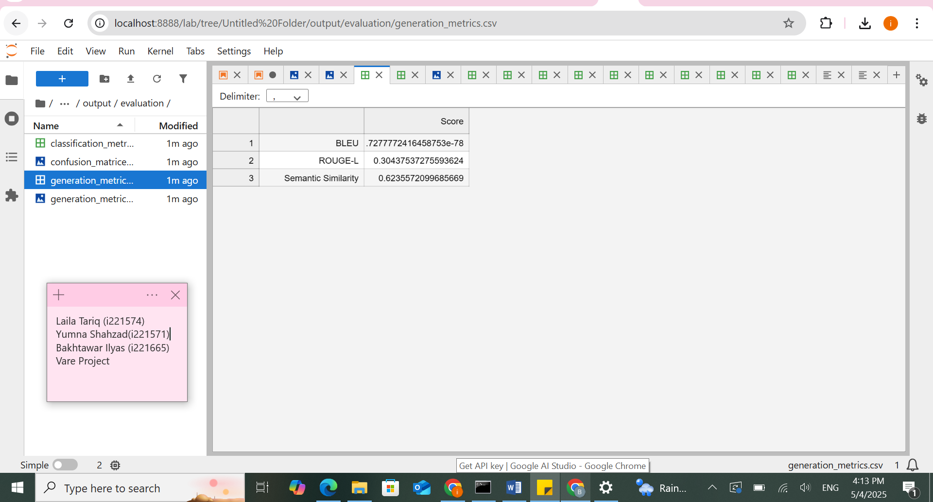

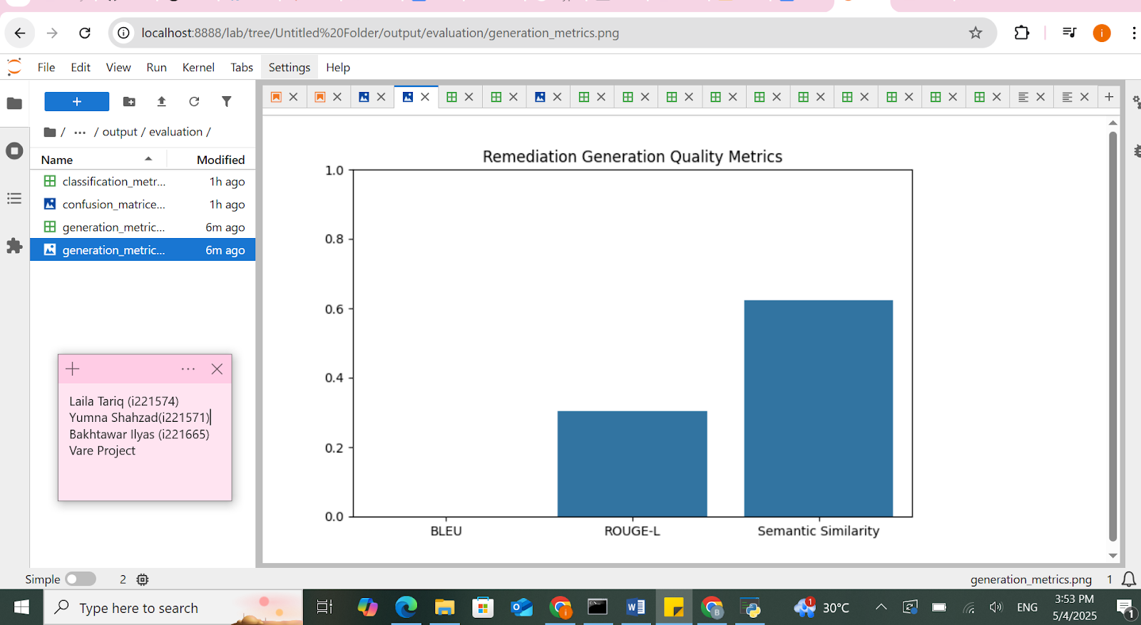

### **Challenges**

1. **Data Issues**

* Parsing and cleaning large JSON files

1. **Model Challenges**

* Imbalanced severity classes
* Mixing text embeddings with CVSS features

1. **API Integration**

* Gemini API rate limits and timeouts
* Handling API errors and formatting prompts

1. **Evaluation**

* No gold standard for remediation text
* BLEU/ROUGE metrics didn’t fully reflect quality

# **Summary**

In this project, we developed a system that scans and prioritizes vulnerabilities using machine learning and AI. We used NVD CVE data and applied Logistic Regression and Random Forest models to classify severity into Low, Medium, High, or Critical. Instead of building our own remediation model, we used Google Gemini’s API to fetch helpful, real-time fixes for each vulnerability. This approach saved time and made the tool more dynamic and relevant. The result is a lightweight yet powerful system that brings intelligence to vulnerability management. It can be extended in the future with live scanning tools and more advanced AI models for even better accuracy.

# **References**

• **National Vulnerability Database (NVD)**

* National Institute of Standards and Technology. National Vulnerability Database. <https://nvd.nist.gov>

• **Google Gemini API**

* Google AI. Gemini 1.5 – Multimodal Generative AI Models. <https://ai.google.dev>

• **Scikit-learn**

* Pedregosa, F., et al. (2011). Scikit-learn: Machine Learning in Python. Journal of Machine Learning Research, 12, 2825–2830. <https://scikit-learn.org>

• **Sentence-BERT (SBERT)**

* Reimers, N., & Gurevych, I. (2019). Sentence-BERT: Sentence Embeddings using Siamese BERT-Networks. EMNLP. <https://www.sbert.net>